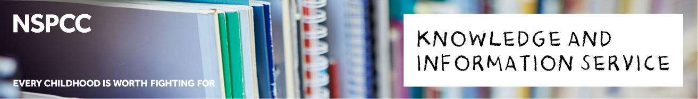

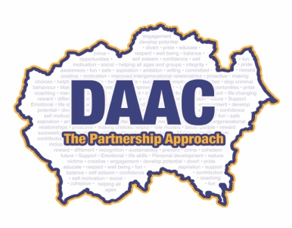

**Durham Agency Against Crime (DAAC)**



This policy reflects the safeguarding needs of the children/young people whom DAAC work with and aligns with other key safeguarding and organisational policies, procedures and standards.



**The purpose and scope of this policy**

The purpose of this policy is:

* to protect children and young people who receive DAAC services. This includes the children of adults who use our services
* to provide parents, staff and volunteers with the overarching principles that guide our approach to child protection.

This policy applies to anyone working on behalf of DAAC, including senior managers and the board of trustees, paid staff, volunteers, sessional workers, agency staff and students.

**Legal framework**

This policy has been drawn up on the basis of legislation, policy and guidance that seeks to protect children in England. A summary of the key legislation is available from [nspcc.org.uk/learning.](http://www.nspcc.org.uk/learning)

Page **1** of 4

|  |
| --- |
| © 2018 NSPCC. Registered charity England and Wales 216401 and Scotland SCO37717. J2014193. |



**Related policies and procedures**

This policy should be read alongside our organisational policiesprocedures, including:

* Role of the designated safeguarding officer
* Dealing with disclosures and concerns about a child or young person
* Managing allegations against staff and volunteers
* Recording and information sharing
* Code of conduct for staff and volunteers
* Safer recruitment
* Online safety
* Anti-bullying
* Managing complaints
* Whistleblowing
* Health and safety
* Induction, training, supervision and support
* Adult to child ratios
* Quality assurance

**We believe that:**

* children and young people should never experience abuse of any kind
* we have a responsibility to promote the welfare of all children and young people, to keep them safe and to practise in a way that protects them.

**We recognise that:**

* the welfare of the child is paramount
* all children, regardless of age, disability, gender reassignment, race, religion or belief, sex, or sexual orientation have a right to equal protection from all types of harm or abuse
* some children are additionally vulnerable because of the impact of previous experiences, their level of dependency, communication needs or other issues
* working in partnership with children, young people, their parents, carers and other agencies is essential in promoting young people’s welfare.

Page **2** of 4

|  |
| --- |
| © 2018 NSPCC. Registered charity England and Wales 216401 and Scotland SCO37717. J2014193. |



**We will seek to keep children and young people safe by:**

* valuing, listening to and respecting them
* appointing a Designated Safeguarding Officer (DSO) for children and young people, deputy (DSO) and a lead board member for safeguarding
* adopting child protection and safeguarding best practice through our policies, procedures and code of conduct for staff and volunteers
* developing and implementing an effective online safety policy and related procedures
* providing effective management for staff and volunteers through supervision, support, training and quality assurance measures
* recruiting staff and volunteers safely, ensuring all necessary checks are made
* recording and storing information professionally and securely
* sharing information about safeguarding and good practice with children, their families, staff, volunteers and service users via leaflets, posters, group work feedback documents and one-to-one discussions
* using our safeguarding procedures to share concerns and relevant information with agencies who need to know, and involving children, young people, parents, families, carers appropriately
* using our procedures to manage any allegations against staff and volunteers appropriately
* creating and maintaining an anti-bullying environment and ensuring that we have a policy and procedure to help us deal effectively with any bullying that does arise
* ensuring that we have effective complaints and whistleblowing measures in place
* ensuring that we provide a safe physical environment for our children, young people, staff and volunteers, by applying health and safety measures in accordance with the law and regulatory guidance.

Page **3** of 4

|  |
| --- |
| © 2018 NSPCC. Registered charity England and Wales 216401 and Scotland SCO37717. J2014193. |



**Contact details**

**Designated Safeguarding Officer (DSO)**

Name: DAAC Executive Manager

Phone/email: 0191 300 8460 bryanr@daac.org.uk

**Deputy DSO(s)**

Name: DAAC Cadet Coordiantor

Phone/email: 0191 300 8460 alisonf@daac.org.uk

**Senior lead for safeguarding**

Name: Insp Paul Mawson. Paul.Mawson@durham.police.uk

Phone/email: 0191 300 8460

**NSPCC Helpline**

0808 800 5000

We are committed to reviewing our policy and good practice **annually.**

**Contact the NSPCC’s Knowledge and Information Service with any questions about child protection or related topics:**

**Tel: 0808 800 5000 | Email:** [**help@nspcc.org.uk**](mailto:help@nspcc.org.uk) **| Twitter:** [**@NSPCCpro**](https://twitter.com/NSPCCpro)

**Copyright © 2018 NSPCC Knowledge and Information Services - All rights reserved.**

Page **4** of 4

|  |
| --- |
| © 2018 NSPCC. Registered charity England and Wales 216401 and Scotland SCO37717. J2014193. |